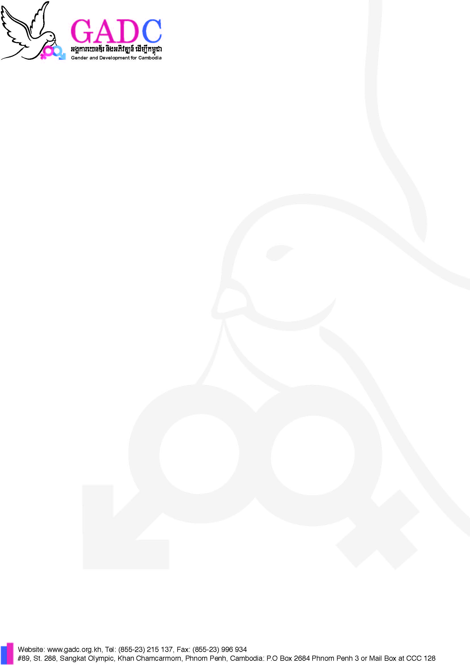

ADV/ REF:

Need Cash date:….10-Dec-21…..
Cash Advance Form

Items Description | Code | Amount |  | Balance
Items Description | Code | Advanced | Actual Exp. | Returned | Reimbursed
Network crimping tool | 5200 | $12
USB/LAN cable tester USB RJ45, RJ11 | 5200 | $9
Network connector | 5200 | $47
Battery | 5200 | $2.5
TOTAL |  | $70.5

Amount in Word (Return/Reimburse):............................................................................................................................

.........................................................................................................................................................................................
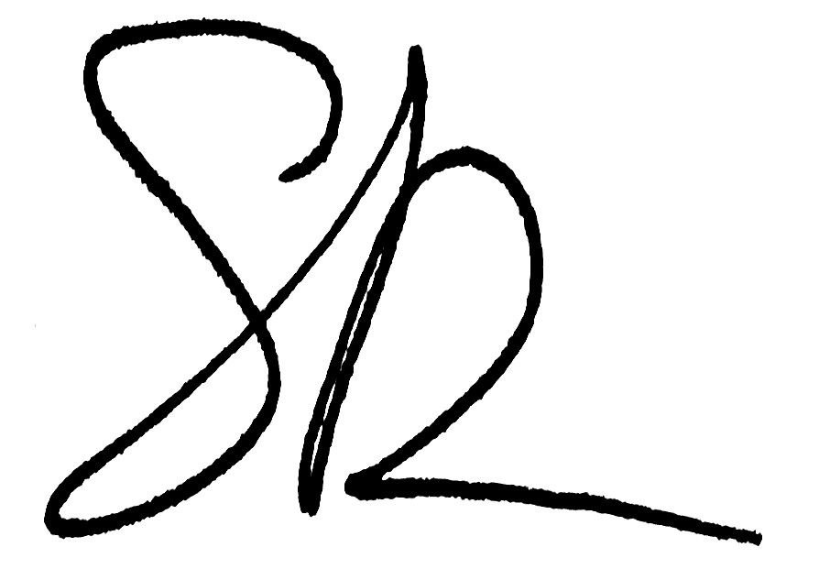
Requested by:…………Sopheak............ .............Signature:............... Date: .....09..../...Dec......./.....21...

Verified by Unit Manager:.................................. Signature:..................................... Date: ............./............../............

Checked by Finance Manager:............................ Signature:...................................... Date............../............../.............

Approved by*:…………………………………. Signature:.................................... Date:............/............../..............
____________________________________________________________________________________________
Before activity implementation: (>$3,000 sign by two people at least)
1st Received by:.................................................. Signature:..................................... Date:.........../............../................

2nd Received by:.................................................. Signature:..................................... Date:.........../............../................

3rd Received by:.................................................. Signature:..................................... Date:.........../............../................
____________________________________________________________________________________________
After activity implementation:
1st Settled by:...................................................... Signature:..................................... Date:.........../............../................

2nd Settled by:..................................................... Signature:..................................... Date:.........../............../................

3rd Settled by:..................................................... Signature:..................................... Date:.........../............../................

Verified by:......................................................... Signature:..................................... Date:.........../............../................
*Refer to Financial Manual, article #14.d “The Unit Manager is responsible to verify the expenditure but limited to approve spending amount up to $100 with approved budget”.

